BUDGET JUSTIFICATION

Lawrence Livermore National Laboratory
- Senior/Key Person
Name | Project Role and Responsibility | Calendar Months | Salary Funds
Lead PI | Lead PI | 9 | $16,679
Computing Scientist | Computing Scientist | 9 | $78,944
 |  |  | $95,623
- Other Personnel
“Not applicable to this project.”
- Equipment
“Not applicable to this project.”
- Travel
“Not applicable to this project.”
- Participant/Trainee Support Costs (if applicable)
“Not applicable to this project.”
- Other Direct Costs
“Not applicable to this project.”
- Direct Costs

Summary of direct costs:
Year 1: $95,623
Year 2: $
Year 3: $
Total Direct Costs: $95,623
- Other Indirect Costs
[$104,377]
- Total Direct and Indirect Costs
Year 1: $200,000
Year 2: $
Year 3: $
Total Indirect Costs: $104,377

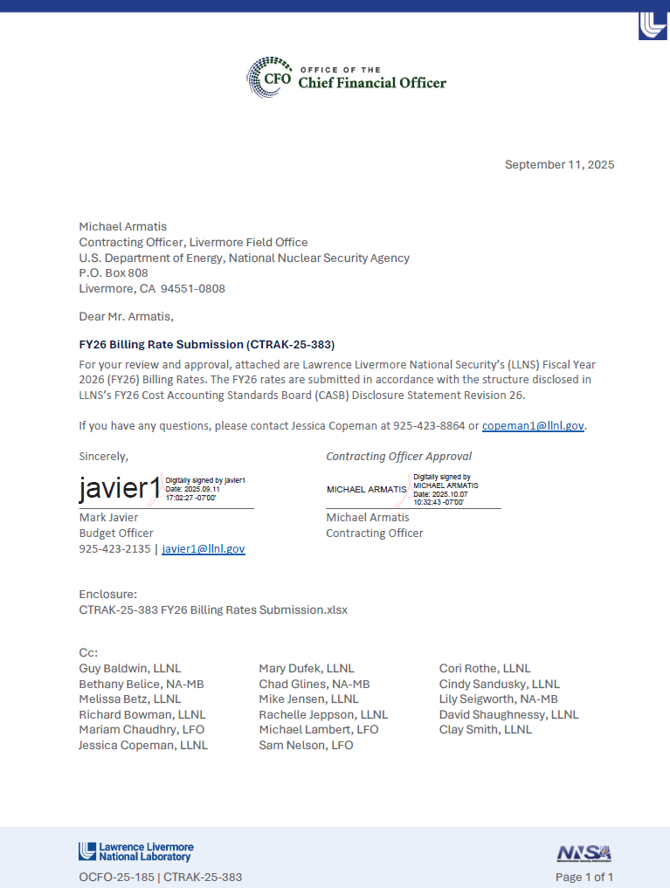
Description of LLNL Burdens
Fringe Benefits
Payroll Burden costs are incurred for employee fringe benefits. Three payroll burden rates are used to reflect the different benefit levels for different appointment types.
1. Payroll Burden – Full: includes accrued vacation cost, sick leave and holidays taken, court and miscellaneous leave with pay, retirement contributions (pension and 401K), health plan contributions, Medicare, Social Security, workman’s compensation insurance, unemployment insurance, and Variable Compensation Plan (VCP)
2. Payroll Burden – Post Doc/College: same as full payroll burden, but excludes employer retirement contributions (pension), employer health plan contributions (retiree), and VCP
3. Payroll Burden – Reduced: same as full payroll burden, but excludes accrued vacation, court leave, employer retirement contributions, employer health contributions, and VCP
General and Administrative Costs:
General & Administrative (G&A) costs are defined as any management, financial, or other expenses that are incurred for the general management and administration of the Laboratory as a whole. G&A activities include senior management administration, external relations & communications, staff relations, legal, internal audit, human resources, CFO (finance, budget, and resource management), procurement, prime contract management, integrated performance and pay administration/workforce management (non-programmatic), tech base (projects that maintain or improve core competencies and capabilities which are multi- programmatic in application), core competencies, outreach, and Special Employees (Post Docs performing institutional activities)
Labor Overhead:
Program Management Charge (PMC) – PAD costs are incurred for managing and administering programs within a Principal Directorate. There are six program PMCs.
1. Computations (COMP): includes COMP program management and policy costs
2. Engineering (ENG): includes ENG program management and policy costs
3. Global Security (GS): includes GS program management, program development, project management, PAD office operations, and Directorate Review Committee (DRC)
4. National Ignition Facility (NIF): includes NIF program management, program development, and PAD office operations
5. Physical and Life Sciences (PLS): includes PLS program management and policy costs
6. Weapons and Complex Integration (WCI): includes WCI program management, program development, and PAD office operations
Program Management Charge (PMC) – Institutional costs are associated with supporting LLNL initiatives and priorities that are multi programmatic including strategic studies related to LLNL missions or in support of decisions to be made by executive leadership, LLNL strategic initiatives that have Lab wide benefit and program development investments that provide capability sustainment to develop and sustain the intellectual base that benefits multiple programs.
Site Support costs are necessary for the management, maintenance, and upgrades of the general purpose facilities and property, and for the provision of basic infrastructure services and safety on site. Activities include computer support, networks, telecommunications, information technology management and services, health services, environmental protection, hazards control, site emergency preparedness, facilities management, facilities maintenance, roads and grounds maintenance, fire protection services, environmental safety & health compliance, institutional scientific infrastructure, shipping, receiving, mail services, and taxi services. Costs in the pool also include Institutional General Purpose Equipment (IGPE) and Institutional General Plant Projects (IGPP), which consists of capital equipment and construction projects of a general use or institutional nature that is required for general purpose site wide needs.
Laboratory Directed Research and Development (LDRD) is an assessment annually approved by the Department of Energy (DOE) that funds research and development work selected by the Laboratory’s Director of designee.
Safeguards and Security Charge (S&S) is utilized as a mechanism to offset LLNL direct funded S&S, Cyber Security (CS), and Hazardous Waste Charge (HWC) costs. Each of the 3 direct funded efforts calculate their contribution to the consolidated S&S pool by their respective ratio of non-DOE Work-for-Other (WFO) and Agreements for Commercializing Technology (ACT) project labor costs divided by total direct labor and LDRD labor costs multiplied by their applicable direct funded base. The rate is allocated to non-DOE WFO and ACT projects and represents the non-DOE WFO and ACT programs’ share of LLNL’s S&S, CS, and HWC costs.
Management Fee is paid to LLNS, LLC for oversight and management of the Laboratory. There are three Management Fee rates:
1. DOE/NNSA fee rate is applied to DOE/DOE WFO/NNSA work, except for those cost estimates where fee is specifically excluded by contract. Maximum available fee is established in the contract and consists of a fixed and performance incentive portion. The fee rate will be allocated to DOE/NNSA work effort, excluding Laboratory Directed Research and Development (LDRD), projects funded by Residual Net Licensing income (royalties), Task Assignment Statements (TAS), ASC and Russian pass through procurements, and Integrated Contractor Order (ICO) procurements.
2. Reimbursable Work fee rate is applied to non-DOE reimbursable work, including DHS. LLNL’s senior management can waive fee from non-DOE reimbursable work at their discretion. Maximum available fee is established by NNSA based on estimated WFO volume prior to the commencement of each fiscal year. The fee rate will be allocated to non-DOE reimbursable work effort. WFO Fee will not be applied to work for which fee has been waived by LLNL senior management, IPAs, Agreements for Commercializing Technology (ACT), or Integrated Contractor Order (ICO) procurements.
3. Agreements for Commercializing Technology (ACT) fee is made to LLNS to assume indemnification and liability associated with the management of the ACT agreements. ACT Fee is negotiated between LLNS and the commercial entity, and allocated to ACT agreements. To meet DOE requirements, ACT Fee will not be reported in DOE’s Standard Accounting and Reporting System (STARS). ACT Fee will not be assessed on the Federal Administrative Charge (FAC).
DOE Federal Administrative Charge (FAC) represents an allocation of DOE’s depreciation and administrative costs (according to full cost recovery provisions) to non-DOE funded projects. FAC is allocated on total costs, including all overhead costs and G&A. FAC is applied to non-DOE funded projects. FAC is not assessed on DHS work.

